HONG KONG INSTITUTE OF VOCATIONAL EDUCATION
Laboratory 9b: Python Web Framework

TASK:
1. Complete the following Coffee Shop Application by following steps below:

- The following Coffee Shop Menu is shown when user access http://localhost:5000
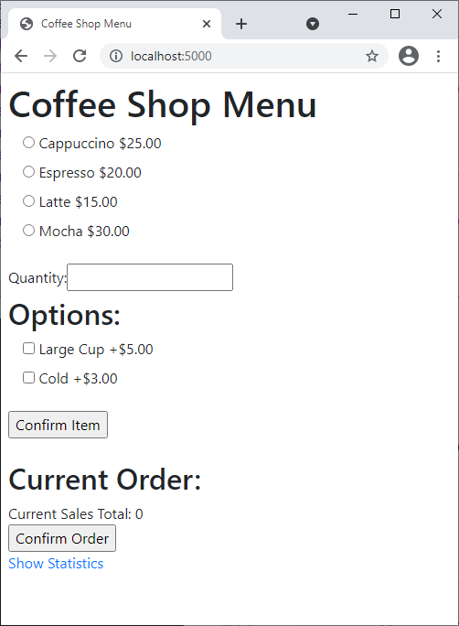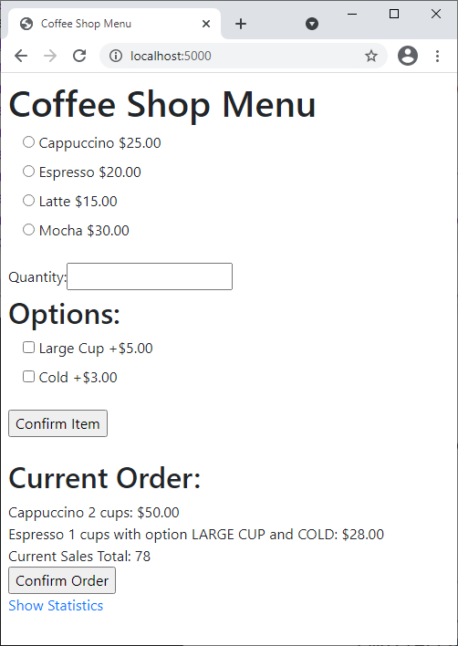

- When user selected appropriated coffee from the radio button, valid quantity number, options (if any) and click the “Confirm Item” button, the form redirects to the same page (i.e. http://localhost:5000) by POST method with new items and sales total included in the “Current Order”. The order would only be confirmed when user click the Confirm Order button.
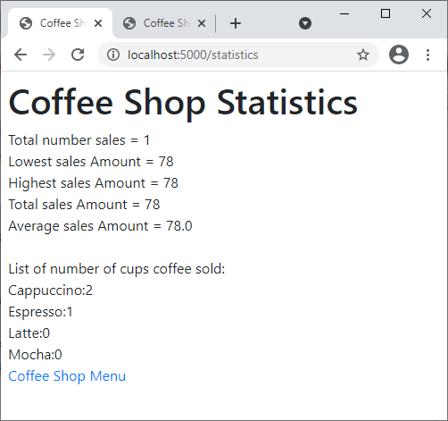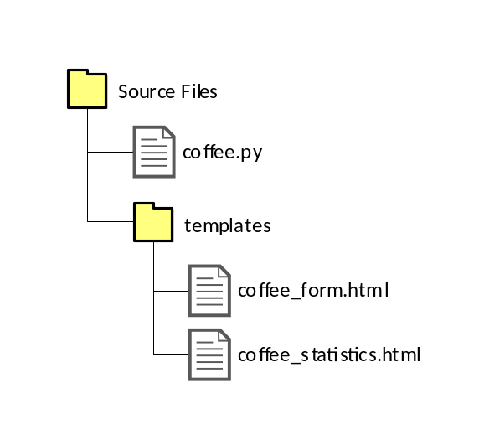
- Name your files using the above hierarchy.
Complete your answers of the following files below:
Hints: You are allowed to use the order class build previously.

Answers: coffee_shop.py

Answers: coffee_form.html

Answers: coffee_statistics.html

